Scholastic Summer Read-a-Palooza Virtual Book Fair email template
Suggested subject line:
Kick-off summer reading with new books!

Copy and paste the image and message below into a new email to promote your Read-a-Palooza Virtual Book Fair to families.

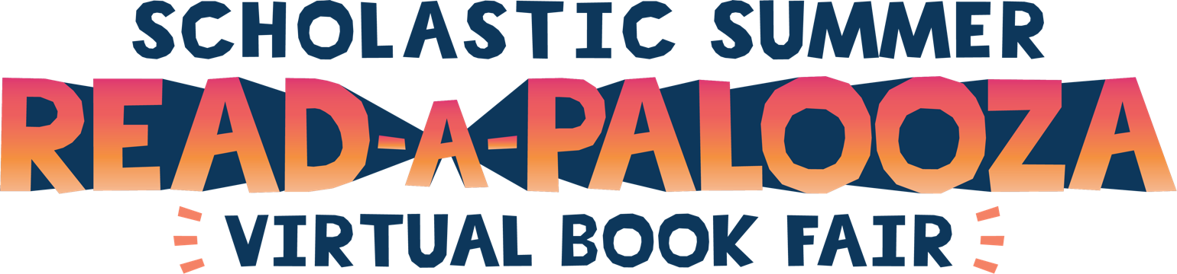
Dear families,
Let’s make this a summer of reading to remember! You’re invited to shop our Read-a-Palooza Virtual Book Fair now through September 4, 2020 to support our school and help students discover favorite characters, series, and collections all summer long.
Stocking up for summer reading has never been easier:
- Find the same exclusive titles as our in-school Book Fair
- Orders ship direct to home
- FREE shipping on book-only orders over $25*
- All purchases benefit our school and earn 25% in rewards

Visit our Book Fair Homepage and click “Shop Now” to get started:
[INSERT HOMEPAGE URL]
Happy reading!
[INSERT SIGNATURE]
*Free standard shipping is available on book-only orders of $25 or more, after all discounts are applied. Free standard shipping (books) must be selected during checkout. Orders containing products other than books are not eligible for this shipping promotion.

